### A PROJECT REPORT

### ON

**“GAME GADGETS”**

**PROJECT SUBMITTED TO THE SAURASHTRA UNIVERSITY RAJKOT**

**FOR THE COURSE OF**

**BACHELOR OF COMPUTER APPLICATIONS**

**SAURASHTRA UNIVERSITY**

##### SUBMITTED BY:

##### BHATT VISHWAS & SANKHAT DARSHAN

**PROJECT ID = 2023501**

**UNDER THE GUIDANCE**

**OF**

**PROF. DR. GAURANG TRIVEDI**

##### FOR FULFILLMENT OF B.C.A (5th SEMESTER)

**SVET COMMERCE & B.B.A. COLLEGE**

##### [NAAC Accredited]

**[Affiliated to Saurashtra University, Rajkot]**

**Saru Section Road, Jamnagar – 361 008**

[**Website: www.svettrust.**](http://Website:%20www.svettrust.)**org, Email: svetcollege@rediffmail.com**



This is to certify that **Bhatt Vishwas & Sankhat Darshan** has completed the project on **Game Gadgets** in partial fulfilment of the required of the **BCA SEM 5th** during the year 2023. The project report has been approved as it satisfies the academic requirement in all respect of project work prescribed by department of computer science, Saurashtra University.

##### Dr. Gaurang Trivedi Dr. Richard Remedios

**H.O.D Principal**

##### Internal Guide

**Name of Examiner Signature of examiner**

**& date**

### ABSTRACT

In contemporary society, there exists a significant level of enthusiasm surrounding games, which extends beyond just entertainment and encompasses various other domains, including employment prospects and opportunities within the realm of e-sports.

Nowadays, the gaming industry is booming with multiple hierarchies, and technological improvements have changed the way games are presented as entertainment. As a modern person, you must have seen and played video games. Because they are such an important part of our life. For that Saurashtra University is providing many courses of computers for students are take the chance for practical knowledge of website and software making.

#### We are very delighted to have part of this Saurashtra University in BCA course in this University, We had a great chance to develop the software for practical knowledge.

**Yours Faithfully,**

**Bhatt Vishwas U.**

**Sankhat Darshan K.**

### ACKNOWLEDGEMENT

In every project, a team of individuals collaborates, and the success of each project is mostly attributed to the motivation, direction, and continuous support provided by these individuals.

We are **Bhatt Vishwas & Sankhat Darshan** students of **S.V.E.T. COMMERCE & BBA COLLEGE, JAMNAGAR** (BCA 5th Sem.) We express our gratitude to **Prof. Dr. Gaurang Trivedi** who assisted us in compiling the project. We would like to express our gratitude to the esteemed faculty members of the institution for their invaluable advice and support, which played a crucial role in the successful completion of this project. Finally, we express our sincere appreciation to our family members and friends who have consistently served as a source of inspiration during the process of preparing this project.

**Thanks From,**

**Bhatt Vishwas U.**

**Sankhat Darshan K.**

**INDEX**

|  |  |  |
| --- | --- | --- |
| **NO** | **TITLE** | **PAGE** |
|  | **TITLEPAGE** | **I** |
|  | **CERTIFICATE** | **II** |
|  | **ABSTRACT** | **III** |
|  | **ACKNOWLEDGEMENT** | **IV** |
| **1** | **PROJECT PROFILE** | **1** |
| **2** | **OLD SYSTEM ANALYSIS**   |  |  | | --- | --- | | **2.1** | **Study of the old system** | | **2.2** | **Problem or weakness of old system** | | **3** |
| **3** | **SCOPE OF NEW SYSTEM** | **5** |
| **4** | **SYSTEM ANALYSIS**   |  |  | | --- | --- | | **4.1** | **Information gathering** | | **4.2** | **Feasibility study** | | **6** |
| **5** | **SYSTEM DESIGN**   |  |  | | --- | --- | | **5.1** | **Data dictionary** | | **5.2** | **Table Normalization** | | **5.3** | **E-R Diagram** | | **5.4** | **DFD** | | **5.5** | **Timeline chart** | | **11** |
| **6** | **SCREENSHOTS** | **25** |
| **7** | **TESTING** | **43** |
| **8** | **MAINTENANCE** | **45** |
| **9** | **LIMITATION AND FEATURES**  **FOR FUTURE ENHANCEMENT** | **46** |
| **10** | **CONCLUSION** | **48** |
| **11** | **BIBLIOGRAPHY** | **49** |

## PROJECT PROFILE

|  |  |
| --- | --- |
| Developed By | Bhatt Vishwas & Sankhat Darshan |
| Project Name | Game Gadgets |
| Project  Language | Front end: PHP  Back end: MYSQL |
| Project Duration | 4 Months |
| Year | 2023 |
| Operating System | Windows 8.1Pro |
| Web Browser | Google Chrome, Microsoft Edge & etc. |
| Submitted  to | S.V.E.T Commerce & BBA College, Jamnagar. |

### PURPOSE OF PROJECT

* The primary objective of the online gaming accessories shop is to enhance the convenience of customers throughout the purchase process.
* The availability of online gaming accessories allows users to conveniently access and see products from any location.

For operating and establishing this project, we are having some

## OBJECTIVES:

1. With the objective to generating financial gain with minimal capital expenditure.
2. In an effort to meet the needs and expectations of our customers, we strive to offer high-quality services at competitive prices.
3. The administration of services at a minimal cost while maintaining high quality standards.

## SCOPE OF PROJECT:

* The system is responsible for managing customer products, item categories, and item data, as well as order tracking and updating.
* The primary objective of this project is to establish and manage a comprehensive database for product records and customer records.
* Therefore, this project has the potential to be utilized in any gaming accessories shops as a means of efficiently managing their records.

## OLD SYSTEM ANALYSIS

## After determining whether, to what extent, and how analysis should be used, it is common to conduct an analysis of the existing system and design a new one.

* 1. **2.1 STUDY OF OLD SYSTEM:**
     + We must acknowledge that outmoded systems create numerous problems.
     + Thus, we decided to create a new endeavor with the finest amenities.
     + Several vulnerabilities in the current system were identified, and some objectives were initiated. The following describes these.
       - Problem or weakness in the manual system:

1. It requires considerable effort.
2. The new system demands objectives.
3. Each user's information needs to be stored manually.
4. It is difficult to rapidly identity available products, their quantities, and item descriptions.
   1. **2.2 PROBLEMS AND WEAKNESS IN OLD SYSTEM:**
      * Although the current system has many features, it also has a number of flaws.
      * The primary issue with the current system is that it contains a great deal of unnecessary information that does not captivate the user.
      * If we are unable to update frequently, the web-based system will quickly become obsolete.

Therefore, it requires upkeep.

## SCOPE OF NEW SYSTEM

* + - Display additional information regarding the content of the products. These specifies are easily understood by all customers.
    - As a website, it has a unique effect on consumers who purchase products from it and attracts them with its features and user-friendly environment.
    - The new system contains several novel features. The system is user-friendly and displays every order detail and status of customers.

## SYSTEM ANALYSIS

### 4.1 INFORMATION GATHERING:

##### Which types of companies are available in your website?

Ans. PlayStation, Xbox, Nintendo, Logitech etc.

##### Is there affordable & reasonable price of all products in your website?

Ans. Yes.

##### Can we give any complaints or any feedback to your website?

Ans. Yes, our website has contact us page where user gives feedback.

##### User can buy any products without registration?

Ans. No, registration is compulsory to buy any products.

##### User can view any products without registration?

Ans. Yes.

##### Do you have online payment in your website?

Ans. No, Currently Unavailable.

##### In the festival do you want to give any new offers to your customers?

Ans. Yes, occasionally in the festival

##### Does your website accepts warranty claims for products?

Ans. No, you have to contact respective company for warranty claims.

##### Do you give “Return Option” of any product for customer in your website?

Ans. Not yet.

##### On your website, do you provide repair services?

Ans. No.

##### On your website, do you provide inventory management?

Ans. Not yet.

##### Do customers can track their order status?

Ans. Yes.

##### Are promotional codes accepted on your website?

Ans. Yes.

##### Can customer share received product’s images or videos on your website?

Ans. No.

##### Does your website provides OTP based authentication?

Ans. Not yet.

### 4.2 FEASIBILITY STUDY:

* A study conducted to determine the practicality of a project, assessing whether it is worthwhile to proceed with its implementation or not. The term used to refer to this process is known as feasibility study.
* There are three elements in the feasibility study portion of the initial study:
  + **Technical Feasibility**
    - Hardware Requirement

CPU - Intel(R) core(Tm) i5-2400 CPU @3.10GHzRAM– 4.00GB

* + - Software Requirement

Browser - Mozilla, Chrome & etc.xampp-v.3.2.2

* + - Network Requirement: Internet connection
  + **Economic Feasibility**
    - Hard disk drive

Gb-500

Price-1599/-

* + - Random access memory

Gb-4(DDR-3)

Price-1400/-

* + - Operating System

Windows8.1 pro (64bit)

Price-8000/-

## ANALYSIS:

Visitors shop name:

# JAY CHAMUNDA GAMES STORE,

# KHODIYAR COLONY, JAMNAGAR-361 006,

Contact: +91-9924632581

* + We visited this shop to gather a lot of details regarding to our project.
  + During our conversation, we have thoroughly discussed upon our products and collected an important amount of information, including the number of companies now operating within the store etc.
  + We have received many information and features about console, controller, monitor, discs, handhelds etc.
  + We seek information regarding the present promotion being implemented on all customer orders for products.
  + We had inquired about the preferences of customers regarding the various possibilities available for purchasing things.

## DESIGN:

* + We have designed login form that caters both the admin side and the user side.
    - We developed admin panel that handles all functionality within the project.

From the perspective of the user

* + A registration form was developed for users.
  + We designed feedback form for users.
  + We have developed a system of categorization that encompasses a wide range of products.
  + Additionally, we have developed items across other categories.

## CODING:

* + The entire project is developed using the PHP Programming language.
  + We provide illustrative instances of website pages
    - index.php
    - register.php
    - login.php
    - product.php

## SYSTEM DESIGN

* 1. **5.1 DATA DICTIONARY :**

## admin

|  |  |  |  |
| --- | --- | --- | --- |
| **FieldName** | **DataType** | **Size** | **Extra** |
| id | Int | 5 | Primary Key |
| username | Varchar | 50 | **-** |
| password | Varchar | 50 | **-** |

1. **users**

|  |  |  |  |
| --- | --- | --- | --- |
| **FieldName** | **DataType** | **Size** | **Extra** |
| id | Int | 5 | PrimaryKey |
| name | Varchar | 50 | **-** |
| username | Varchar | 50 | **-** |
| password | Varchar | 50 | **-** |
| email | Varchar | 50 | **-** |
| phno | Bigint | 10 | **-** |

## category

|  |  |  |  |
| --- | --- | --- | --- |
| **FieldName** | **DataType** | **Size** | **Extra** |
| id | Int | 5 | PrimayKey |
| category_nm | Varchar | 50 | **-** |

1. **product**

|  |  |  |  |
| --- | --- | --- | --- |
| **FieldName** | **Data Type** | **Size** | **Extra** |
| id | Int | 5 | Primary key |
| category_id | Int | 5 | Foreign key |
| name | Varchar | 100 | **-** |
| mrp | Float | - | **-** |
| selling_price | Float | - | **-** |
| image | Varchar | 200 | **-** |
| description | Varchar | 500 | **-** |

1. **cart**

|  |  |  |  |
| --- | --- | --- | --- |
| **Fieldname** | **Data Type** | **Size** | **Extra** |
| id | Int | 5 | Primary Key |
| uid | Int | 5 | Foreign Key |
| pid | Int | 5 | Foreign  Key |
| image | Varchar | 100 | **-** |
| name | Varchar | 100 | **-** |
| price | Float | - | **-** |
| qty | Int | 2 | **-** |

## contact_us

|  |  |  |  |
| --- | --- | --- | --- |
| **Fieldname** | **Data Type** | **Size** | **Extra** |
| id | Int | 5 | PrimaryKey |
| name | Varchar | 50 | **-** |
| email | Varchar | 100 | **-** |
| message | Varchar | 200 | **-** |

## orders

|  |  |  |  |
| --- | --- | --- | --- |
| **FieldName** | **Data Type** | **Size** | **Extra** |
| id | Int | 5 | Primary  Key |
| uid | Int | 5 | Foreign  Key |
| full_name | Varchar | 50 | - |
| email | Varchar | 100 | **-** |
| phno | Bigint | 10 | **-** |
| address | Varchar | 200 | **-** |
| city | Varchar | 50 | **-** |
| country | Varchar | 50 | **-** |
| state | Varchar | 50 | **-** |
| zip | Bigint | 6 | **-** |
| pay_mode | Varchar | 50 | **-** |
| total_price | Float | - | **-** |
| promo_code | Varchar | 50 | **-** |
| rate | Float | - | **-** |
| discount | Float | - | **-** |
| discounted_price | Float | - | **-** |
| date | Date | - | **-** |
| status | Int | 1 | **-** |

## order_details

|  |  |  |  |
| --- | --- | --- | --- |
| **FieldName** | **DataType** | **Size** | **Extra** |
| id | Int | 5 | PrimayKey |
| order_id | Int | 5 | ForeignKey |
| uid | Int | 5 | ForeignKey |
| pid | Int | 5 | ForeignKey |
| image | Varchar | 100 | **-** |
| name | Varchar | 100 | **-** |
| price | Float | - | **-** |
| qty | Int | 2 | **-** |

## promo_code

|  |  |  |  |
| --- | --- | --- | --- |
| **FieldName** | **DataType** | **Size** | **Extra** |
| id | Int | 5 | Primary Key |
| code | Varchar | 50 | **-** |
| rate | Float | - | **-** |

* 1. **5.2 TABLE NORMALIZATION:**

## admin:

* **BEFORE NORMALIZATION**

|  |  |  |  |
| --- | --- | --- | --- |
| **Fieldname** | **Data Type** | **Size** | **Extra** |
| id | Int | 5 | Primay Key |
| fnm | Varchar | 50 | **-** |
| lnm | Varchar | 50 | **-** |
| username | Varchar | 50 | **-** |
| password | Varchar | 50 | **-** |

## AFTER NORMALIZATION

|  |  |  |  |
| --- | --- | --- | --- |
| **FieldName** | **DataType** | **Size** | **Extra** |
| id | Int | 5 | Primary Key |
| username | Varchar | 50 | **-** |
| password | Varchar | 50 | **-** |

1. **users:**

## BEFORE NORMALIZATION

|  |  |  |  |
| --- | --- | --- | --- |
| **FieldName** | **DataType** | **Size** | **Extra** |
| id | Int | 5 | PrimaryKey |
| fnm | Varchar | 50 | **-** |
| lnm | Varchar | 50 | **-** |
| unm | Varchar | 50 | **-** |
| password | Varchar | 50 | **-** |
| email | Varchar | 50 | **-** |
| city | Varchar | 50 | **-** |
| state | Varchar | 50 | **-** |
| country | Varchar | 50 | **-** |
| address | Varchar | 100 | **-** |
| phno | Bigint | 10 | **-** |

* **AFTER NORMALIZATION**

|  |  |  |  |
| --- | --- | --- | --- |
| **FieldName** | **DataType** | **Size** | **Extra** |
| id | Int | 5 | Primary Key |
| name | Varchar | 50 | **-** |
| username | Varchar | 50 | **-** |
| password | Varchar | 50 | **-** |
| email | Varchar | 50 | **-** |
| phno | Bigint | 10 | **-** |

## cart:

* **BEFORE NORMALIZATION**

|  |  |  |  |
| --- | --- | --- | --- |
| **FieldName** | **DataType** | **Size** | **Extra** |
| id | Int | 5 | PrimaryKey |
| unm | Varchar | 50 | **-** |
| user_city | Varchar | 50 | **-** |
| phno | BigInt | 10 | **-** |
| email | varchar | 50 | **-** |
| pnm | Varchar | 50 | **-** |

|  |  |  |  |
| --- | --- | --- | --- |
| qty | Int | 2 | **-** |
| rate | BigInt | 10 | **-** |
| pimg | Varchar | 50 | **-** |

## AFTER NORMALIZATION

|  |  |  |  |
| --- | --- | --- | --- |
| **FieldName** | **DataType** | **Size** | **Extra** |
| id | Int | 5 | PrimaryKey |
| uid | Int | 5 | ForeignKey |
| pid | Int | 5 | ForeignKey |
| image | Varchar | 100 | **-** |
| name | Varchar | 100 | **-** |
| price | Float | - | **-** |
| qty | Int | 2 | **-** |

### 5.3 E-R DIAGRAM

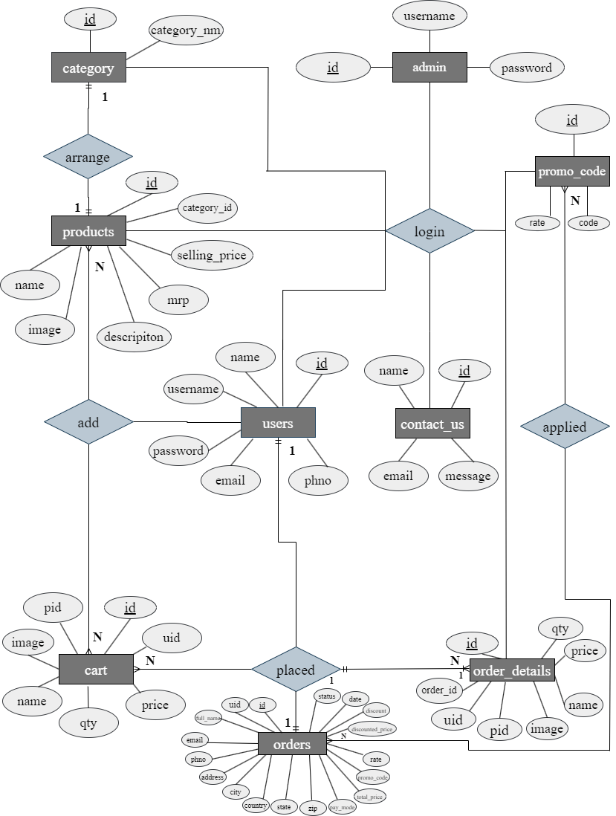

* 1. **5.4 DATA FLOW DIAGRAM**

## CONTEXT LEVEL DFD

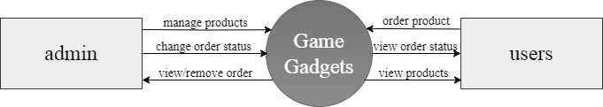

* **0 LEVEL DFD**

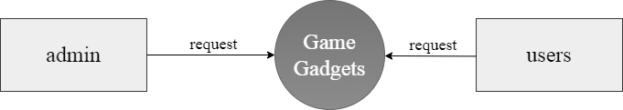

* **1 LEVEL DFD**

**Admin side:**

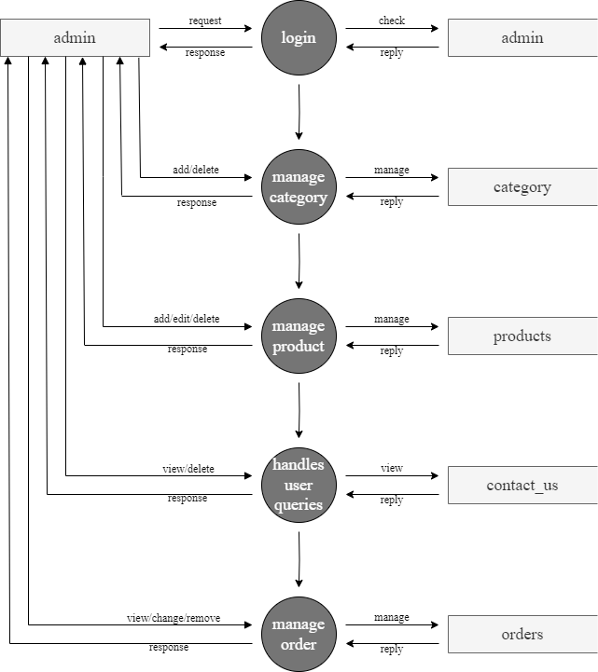

**User side:**

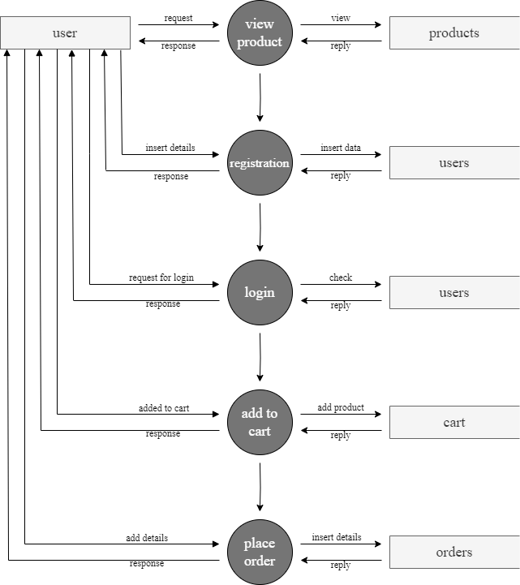

### 5.5 TIMELINECHART

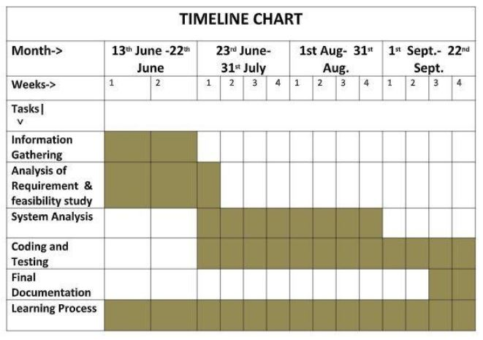

**6) SCREENSHOTS**

# Admin side

## Admin Login:

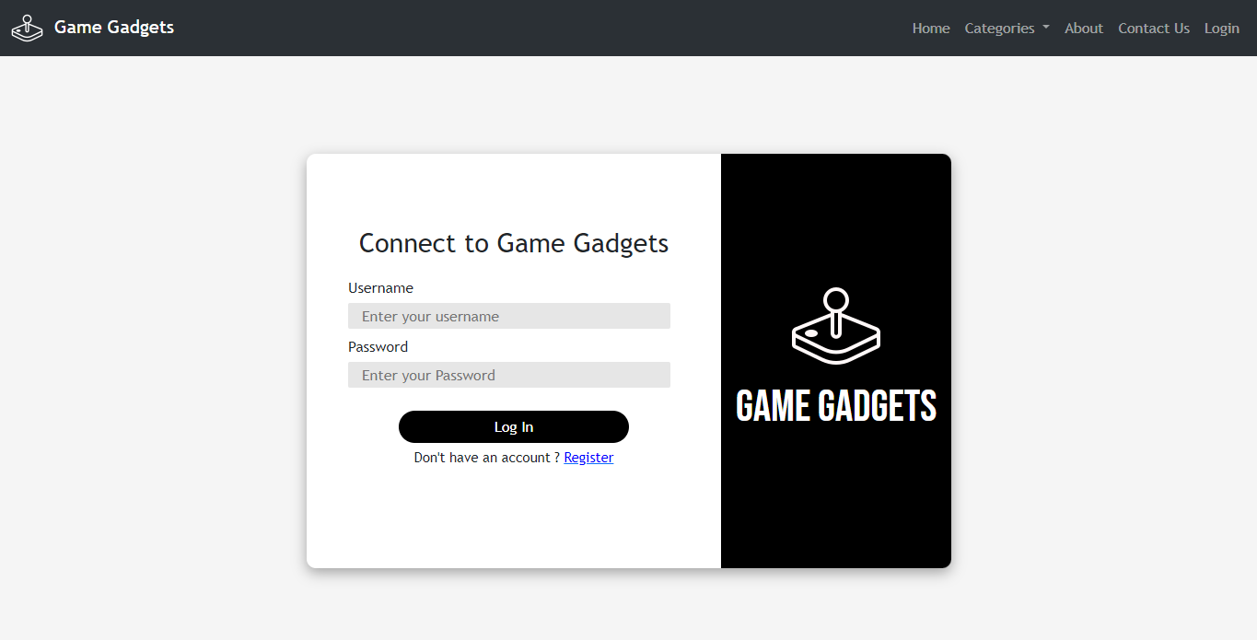

## Add Category:

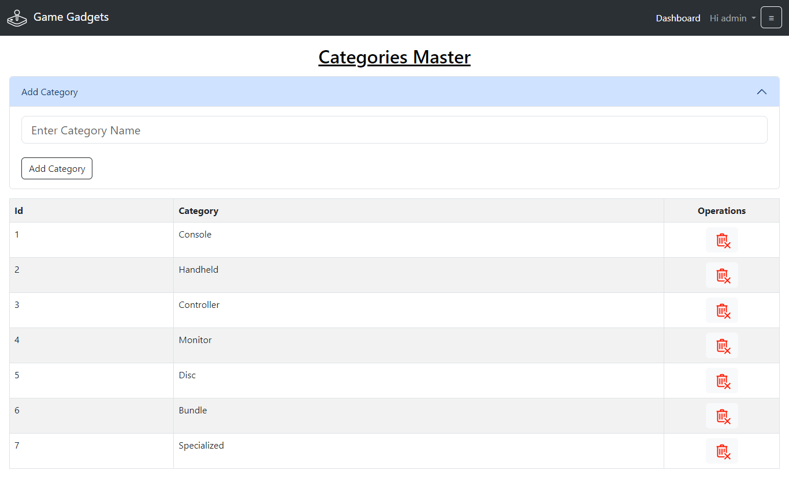

1. **Add Product:**

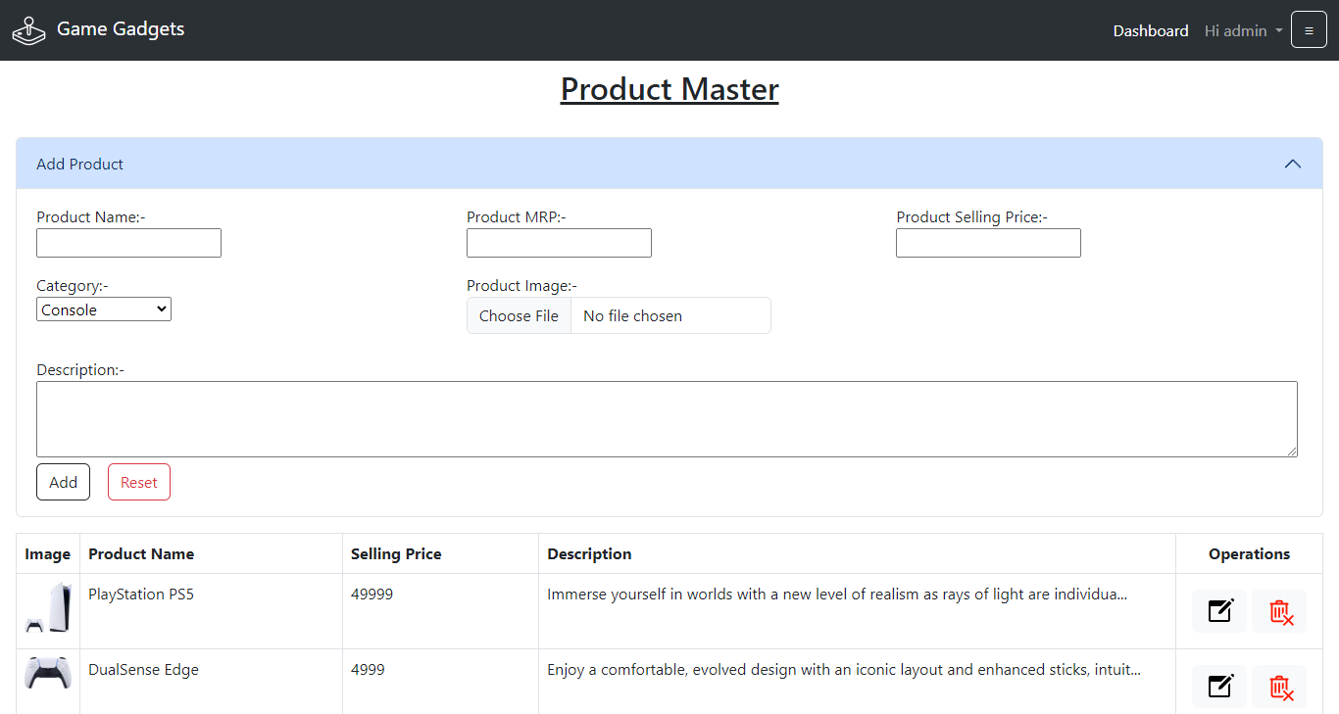

## Edit Product:

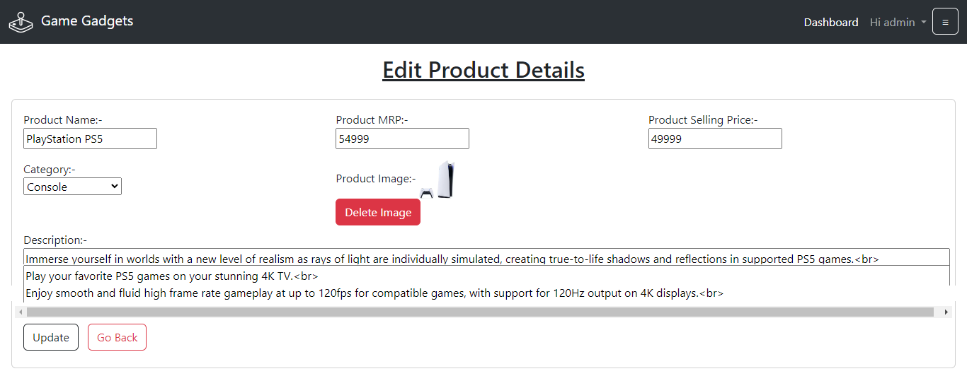

1. **Feedback:**

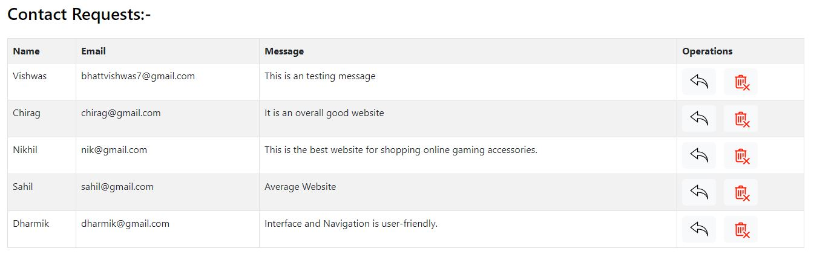

1. **Order Details:**

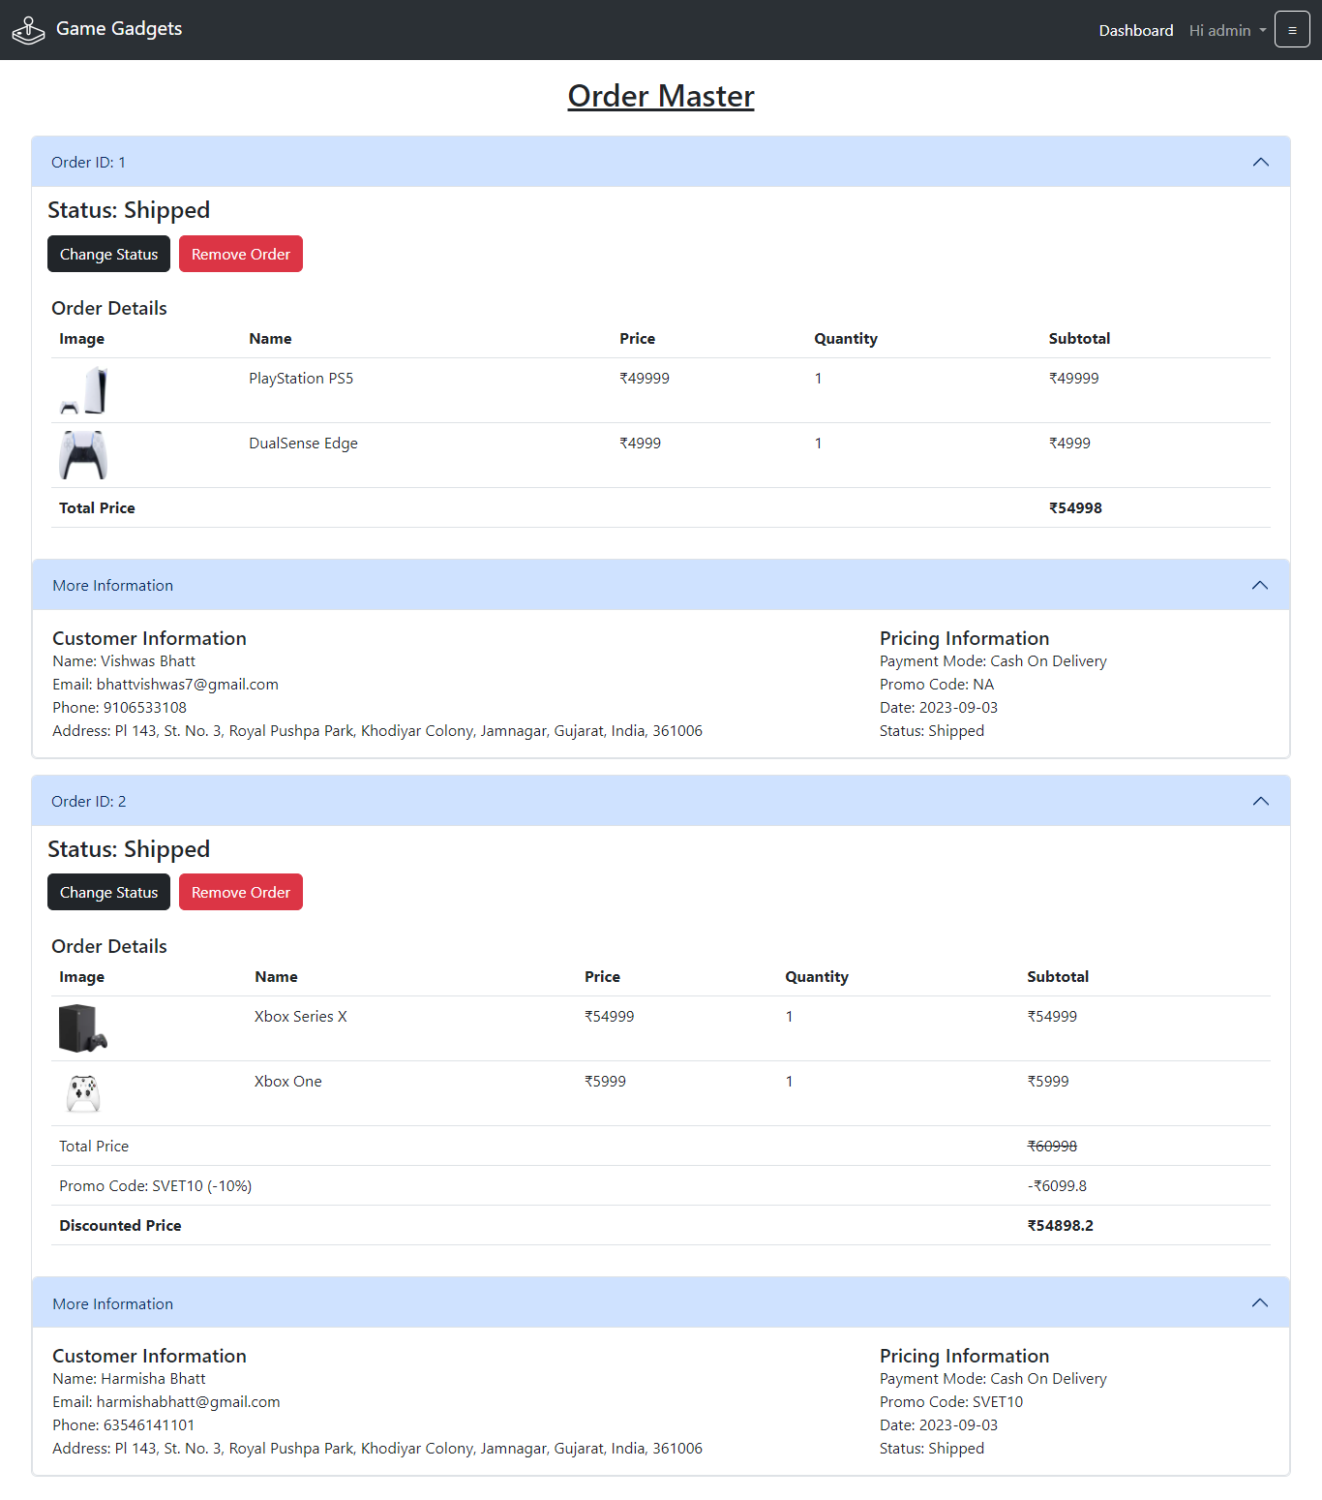

# User side

## User Login:



1. **Registration:**

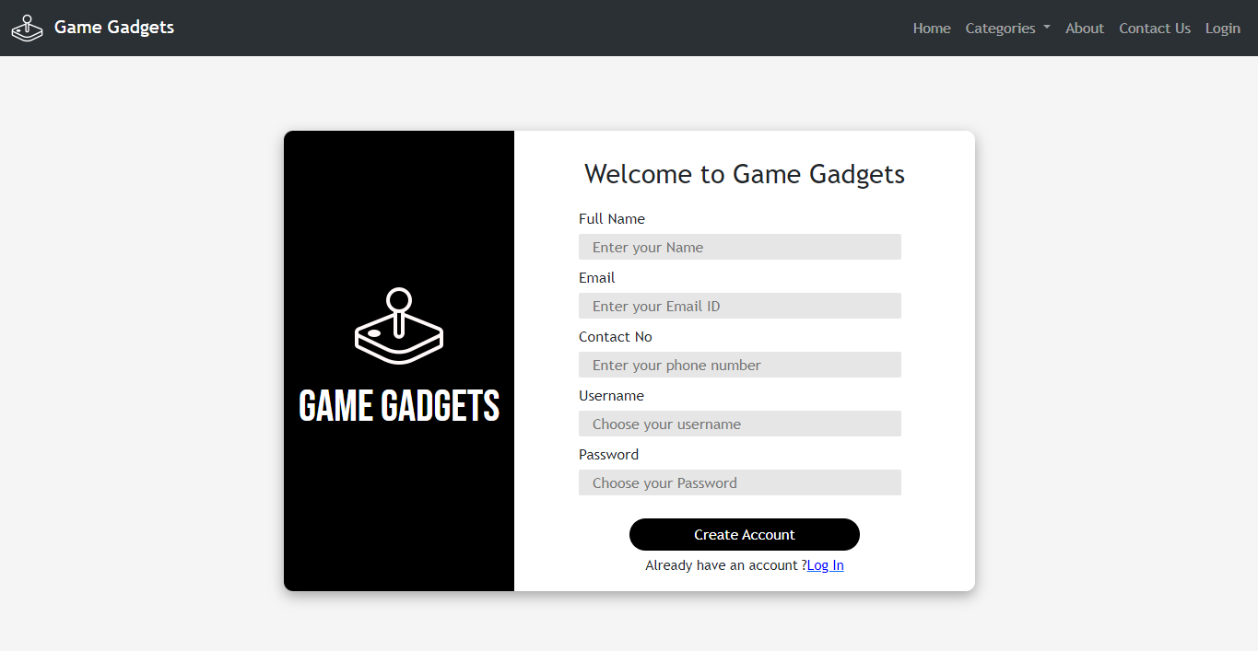

## Homepage:

## 

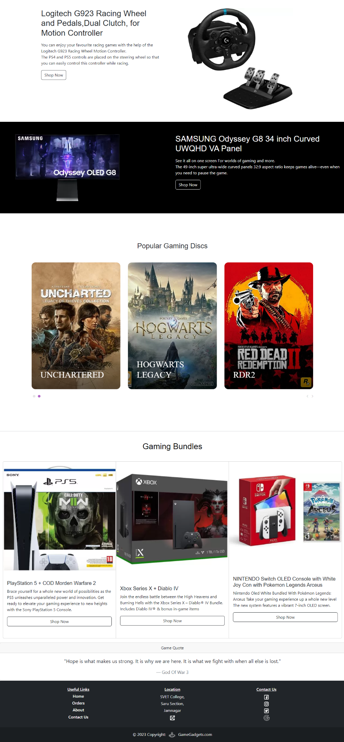

1. **Console:**

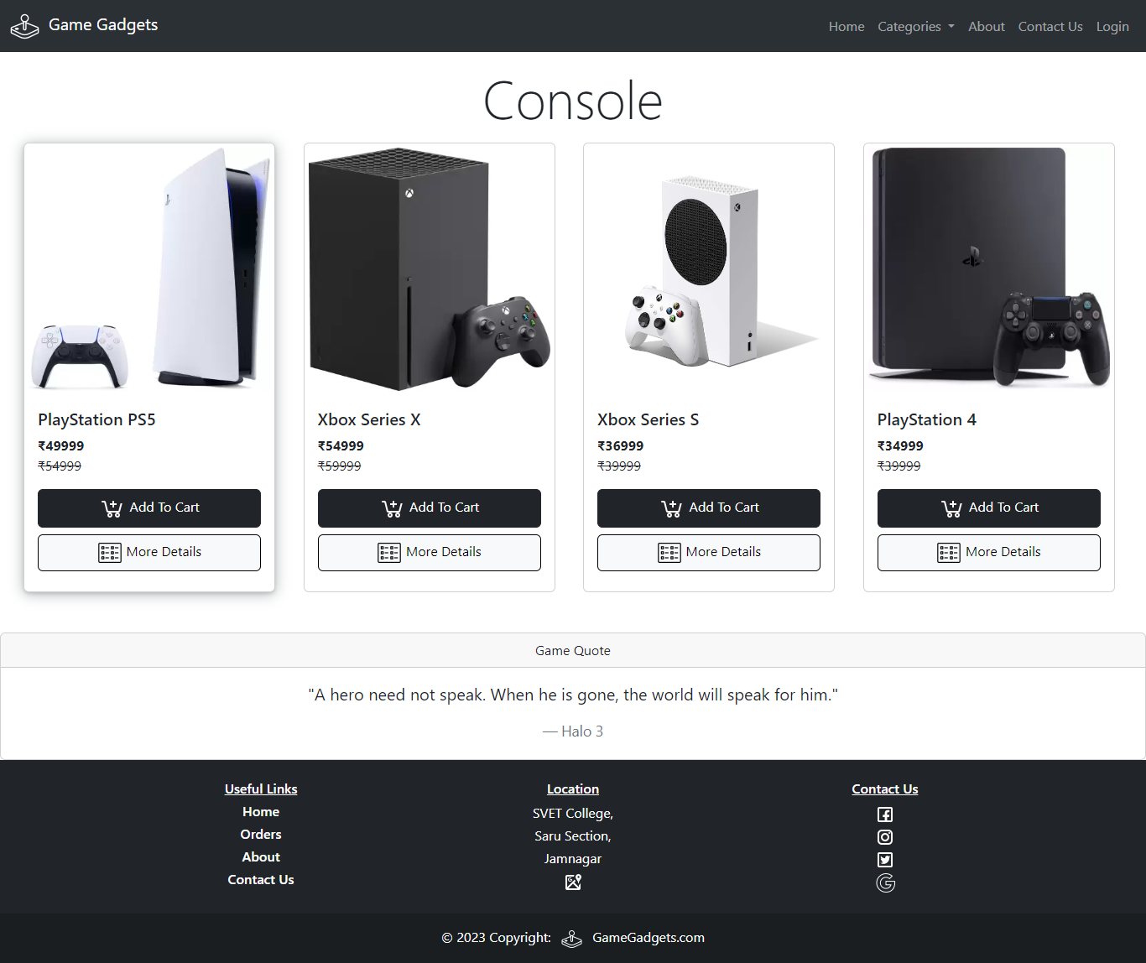

## Handheld:

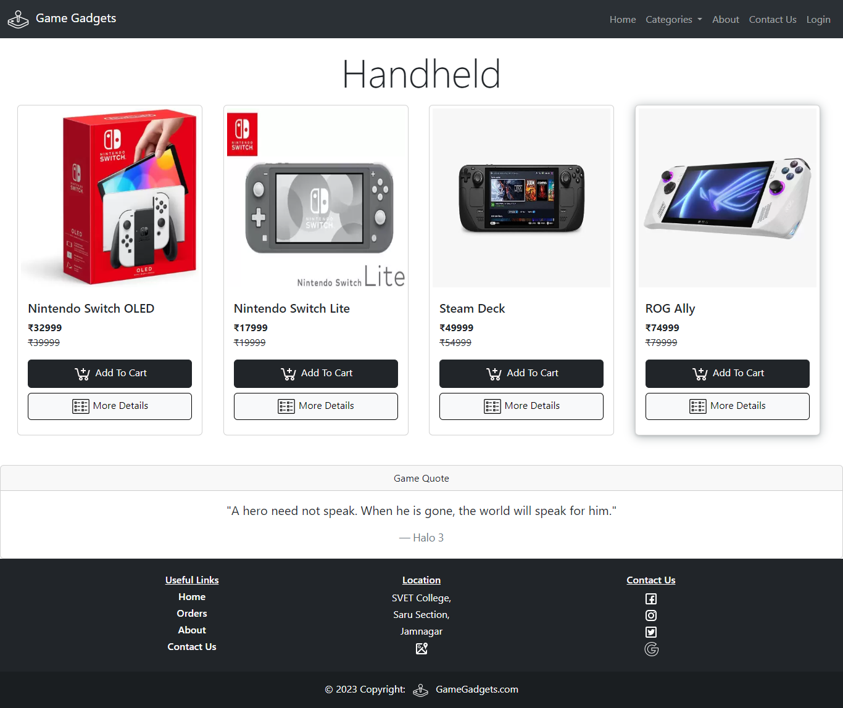

1. **Controller:**

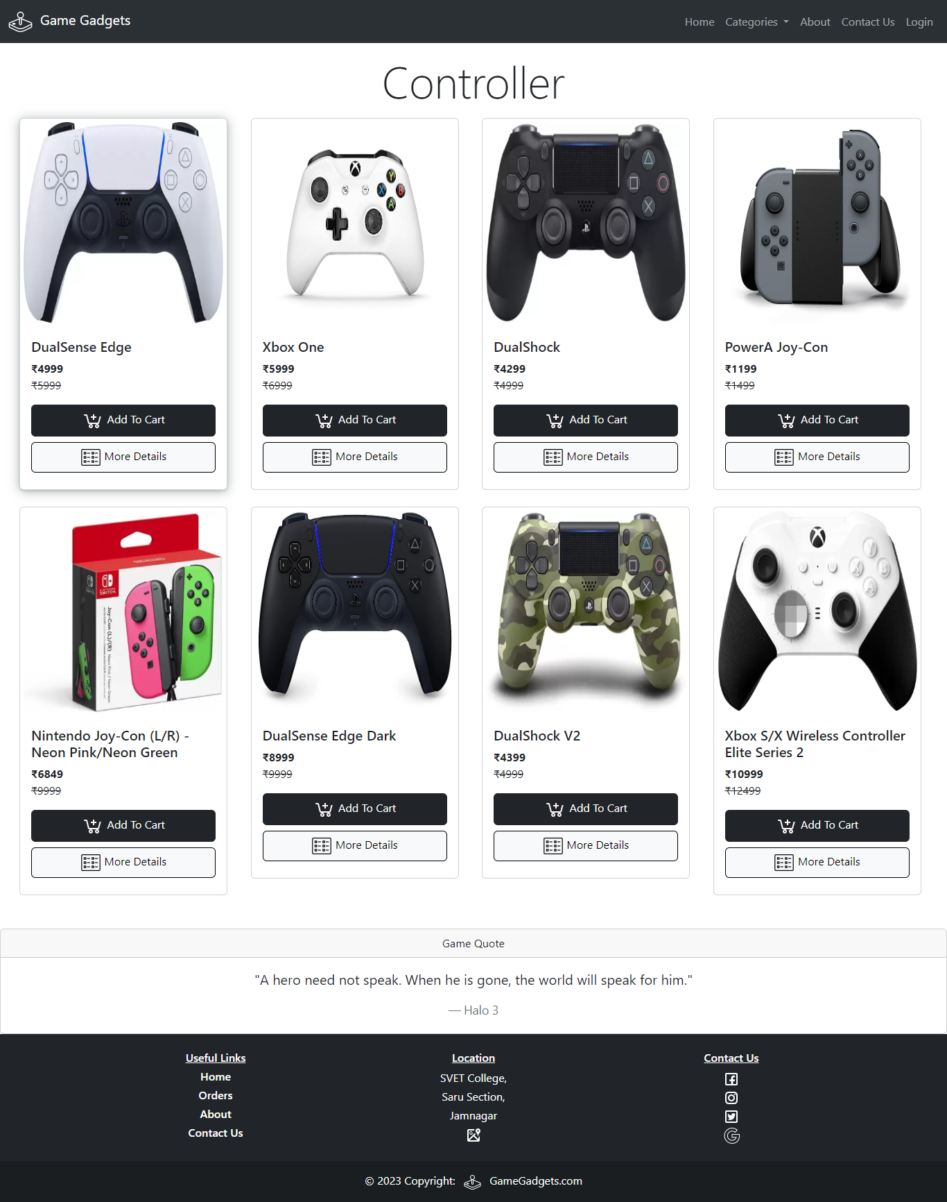

## Disc:

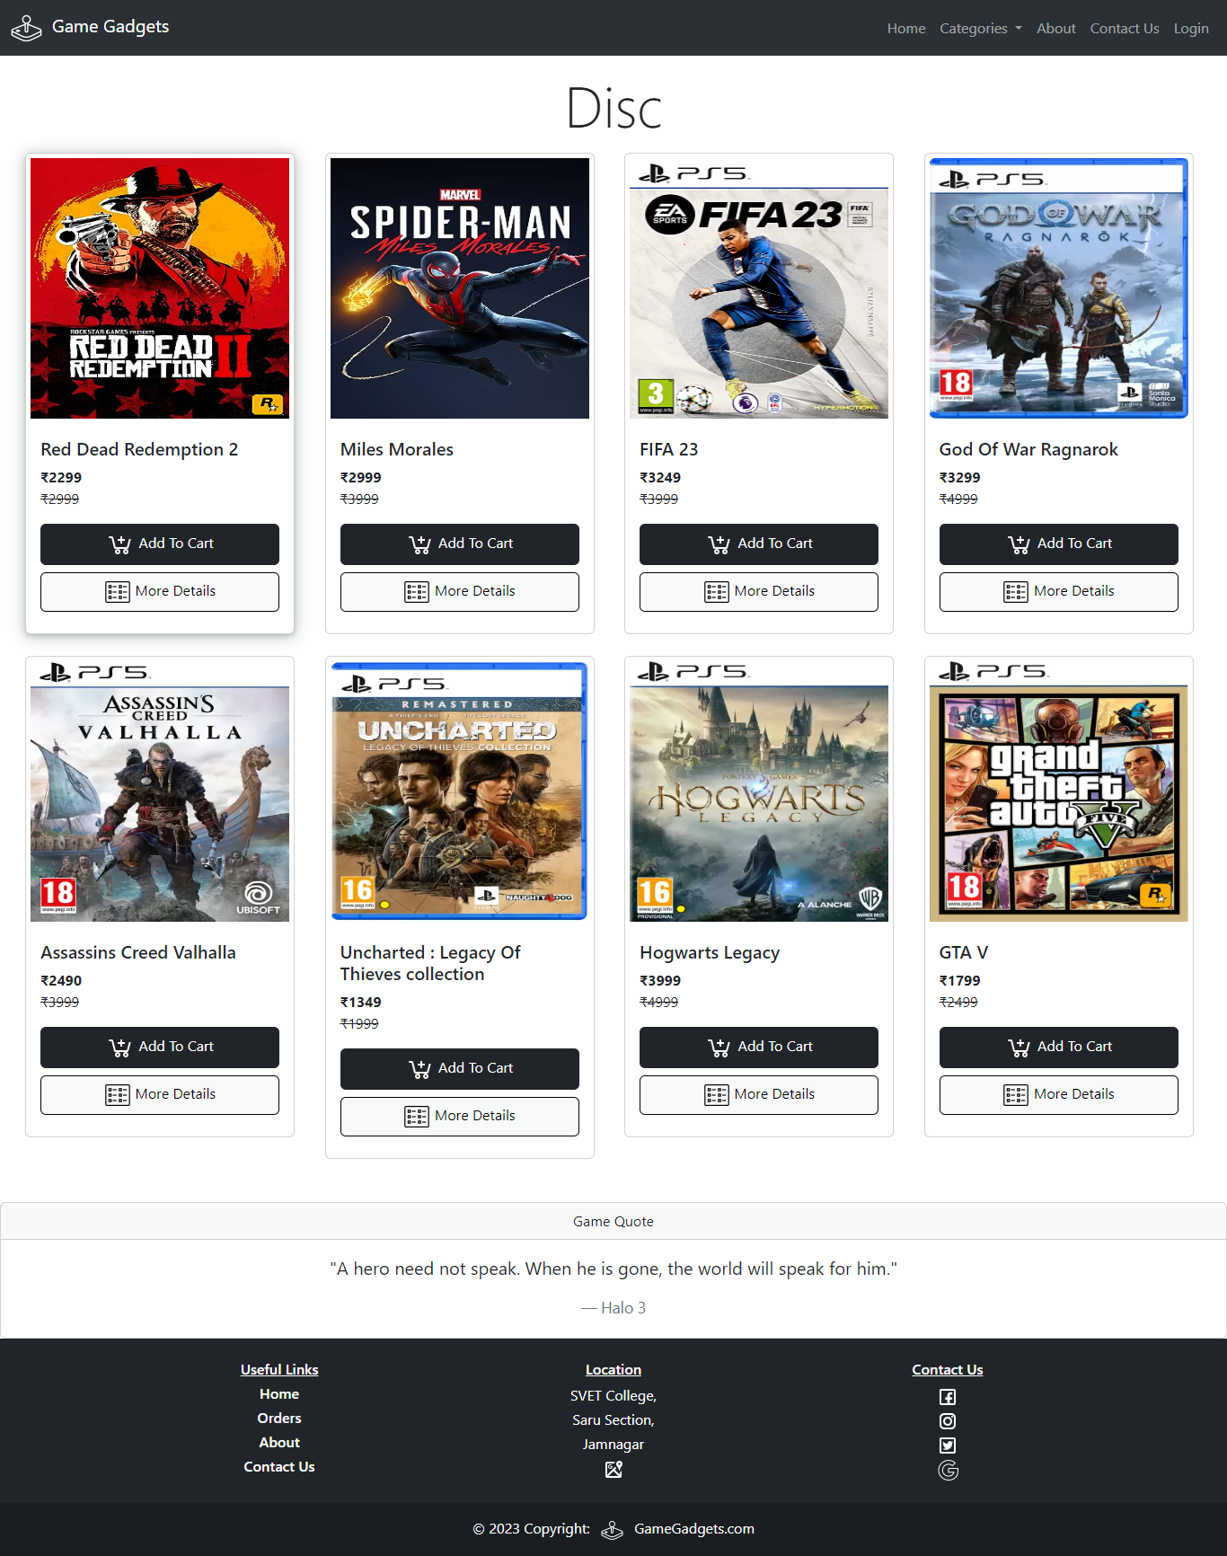

1. **Monitor:**

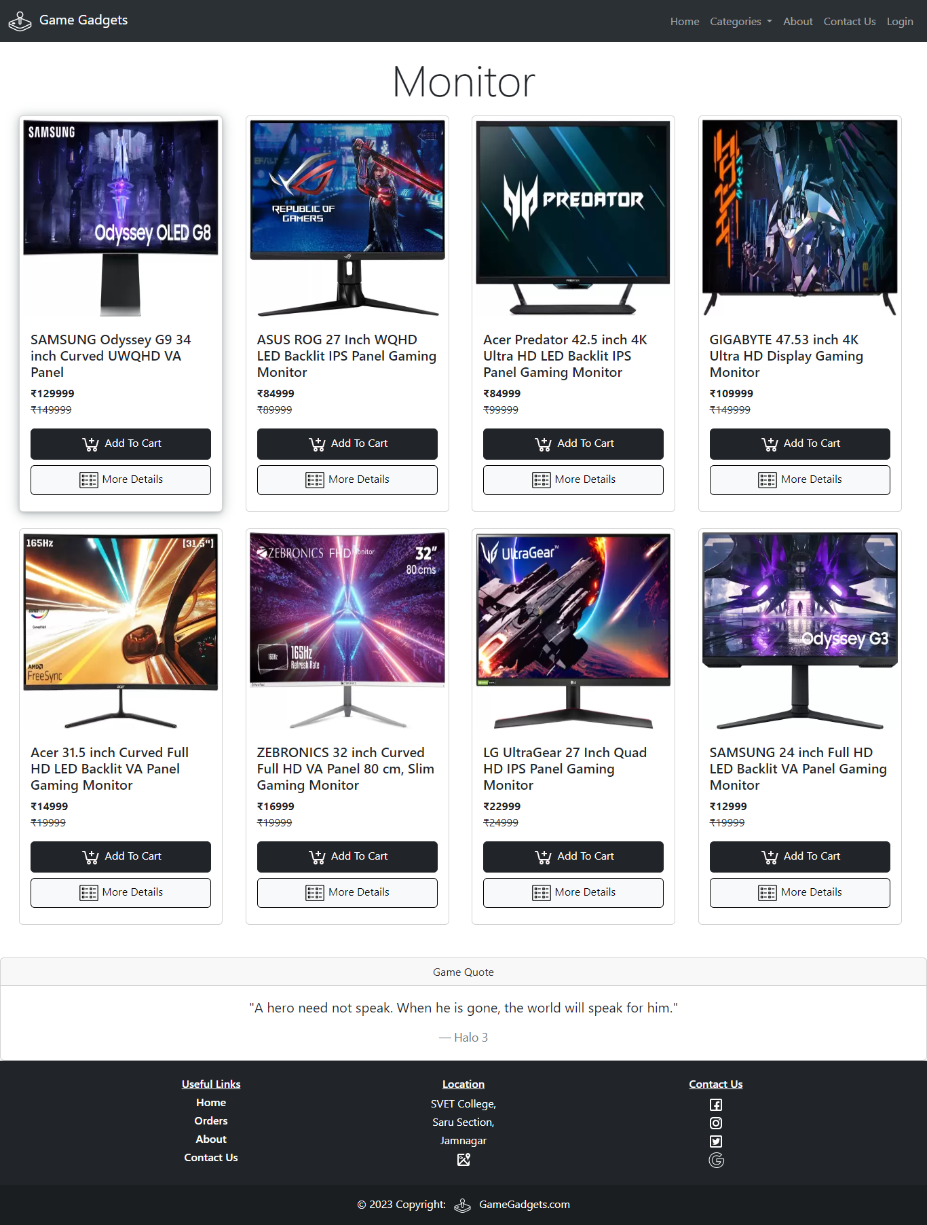

## Bundle:

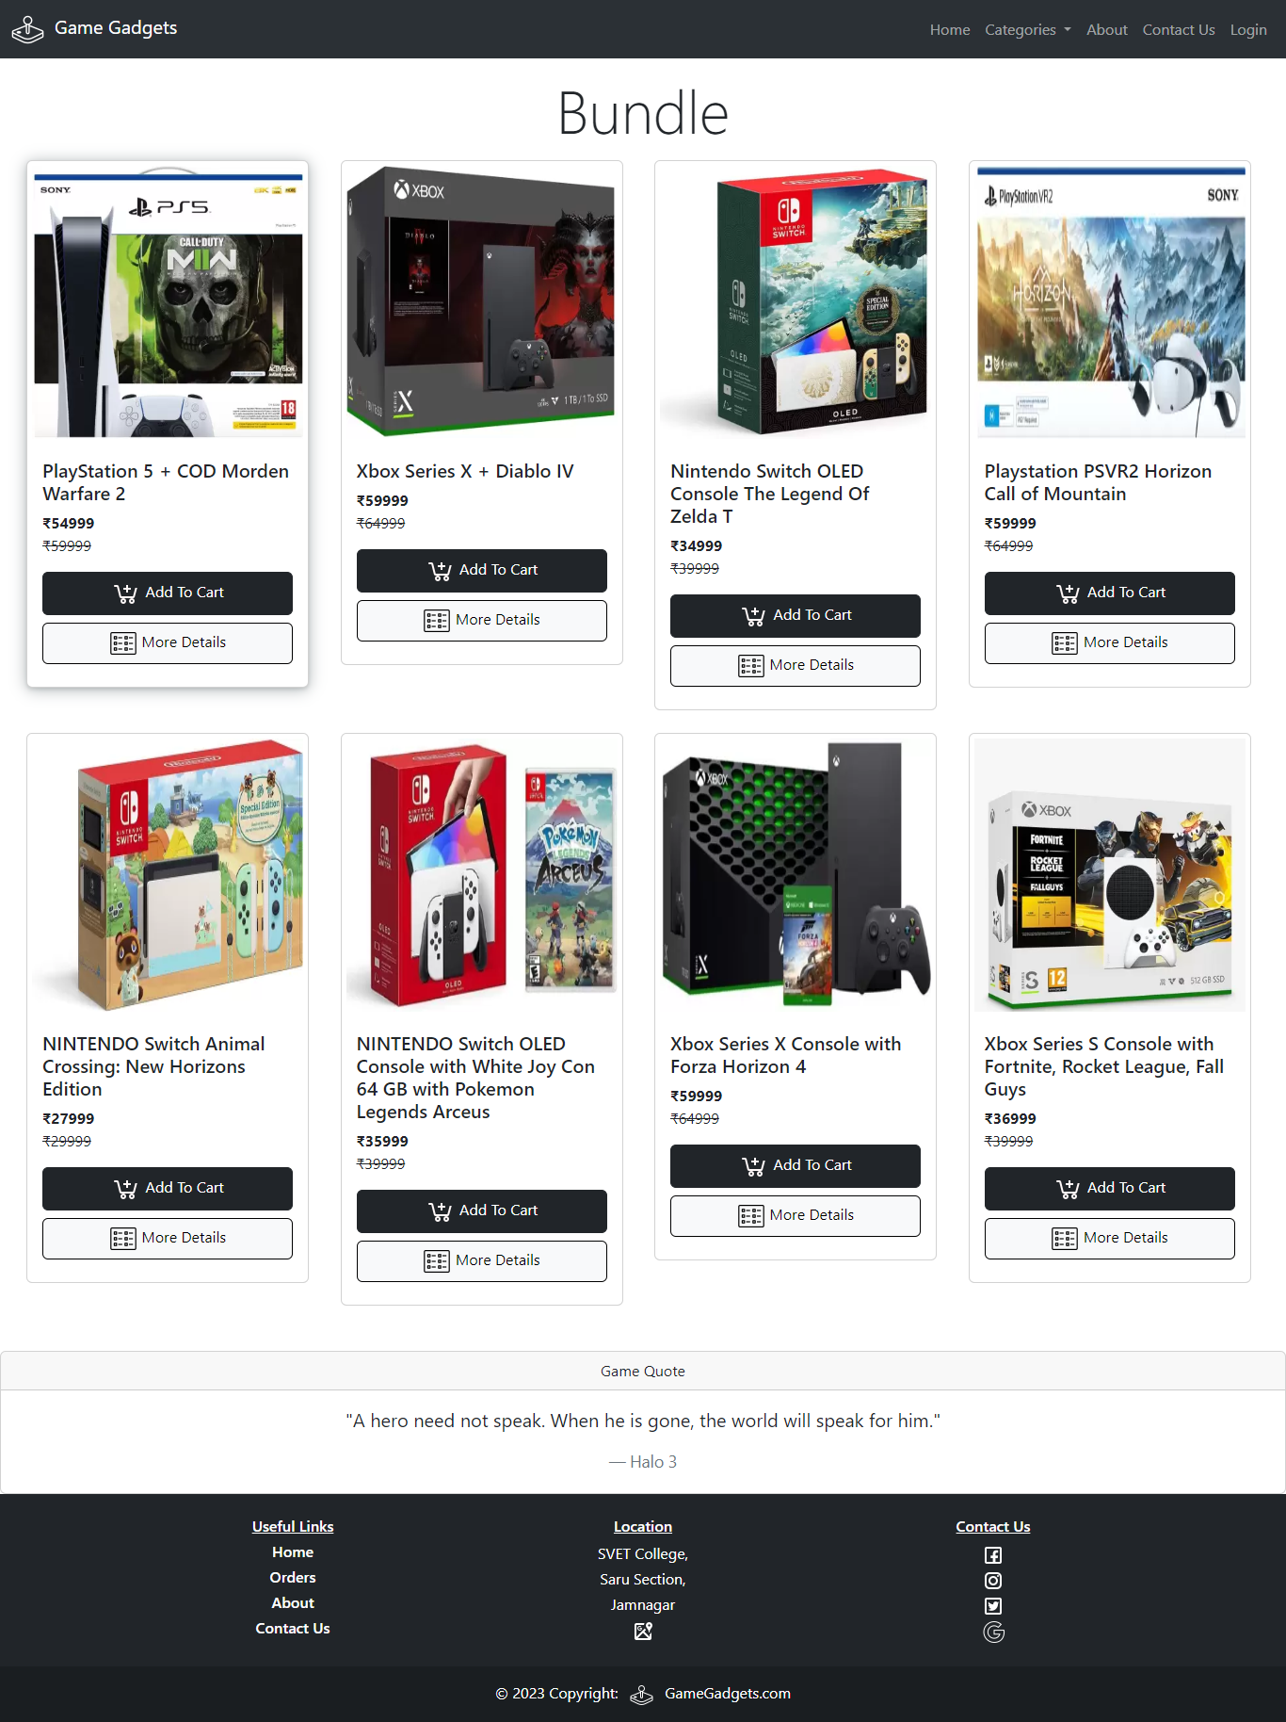

1. 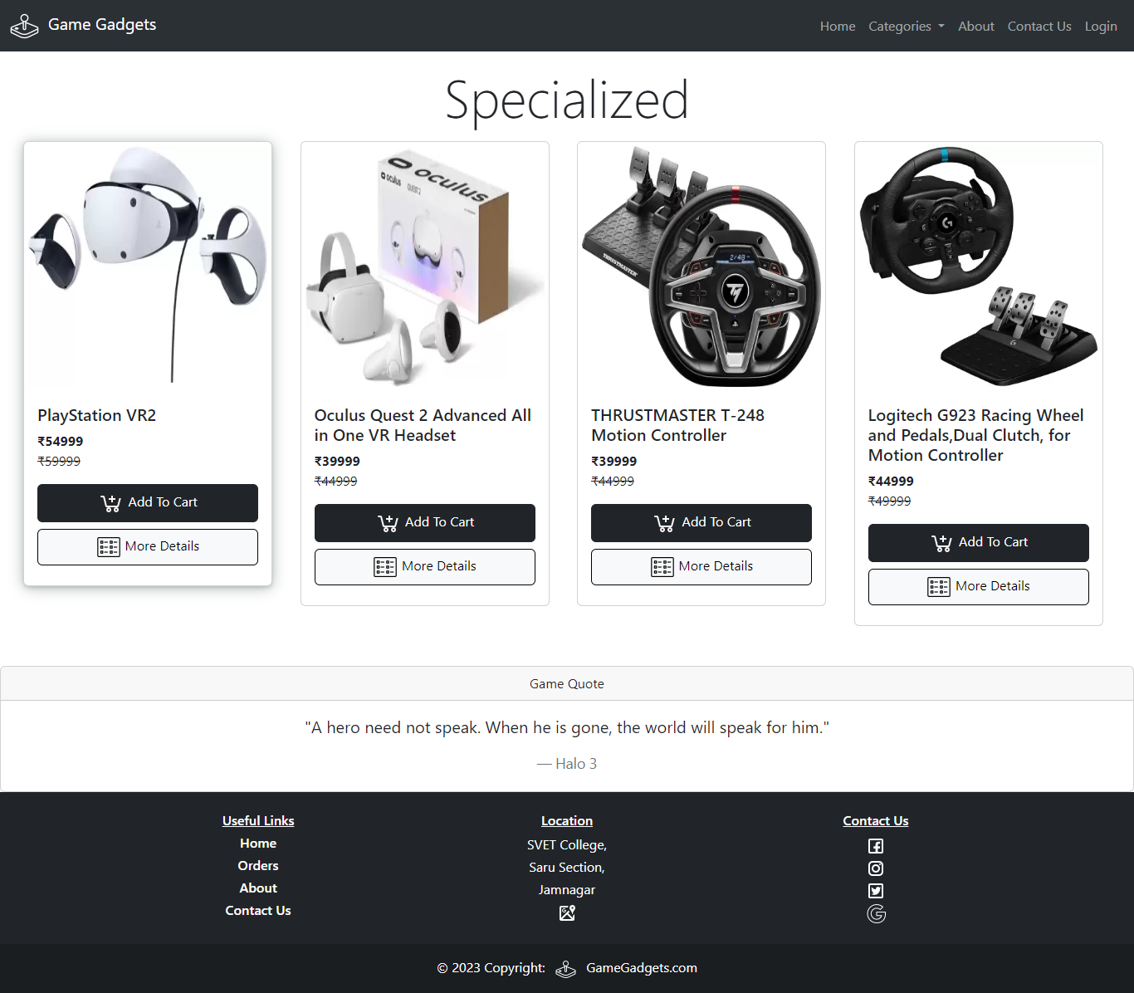**Specialized:**

## Cart Page:

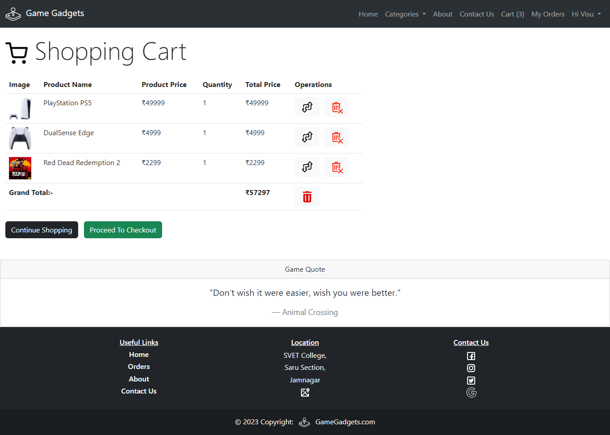

1. **Contact Us:**

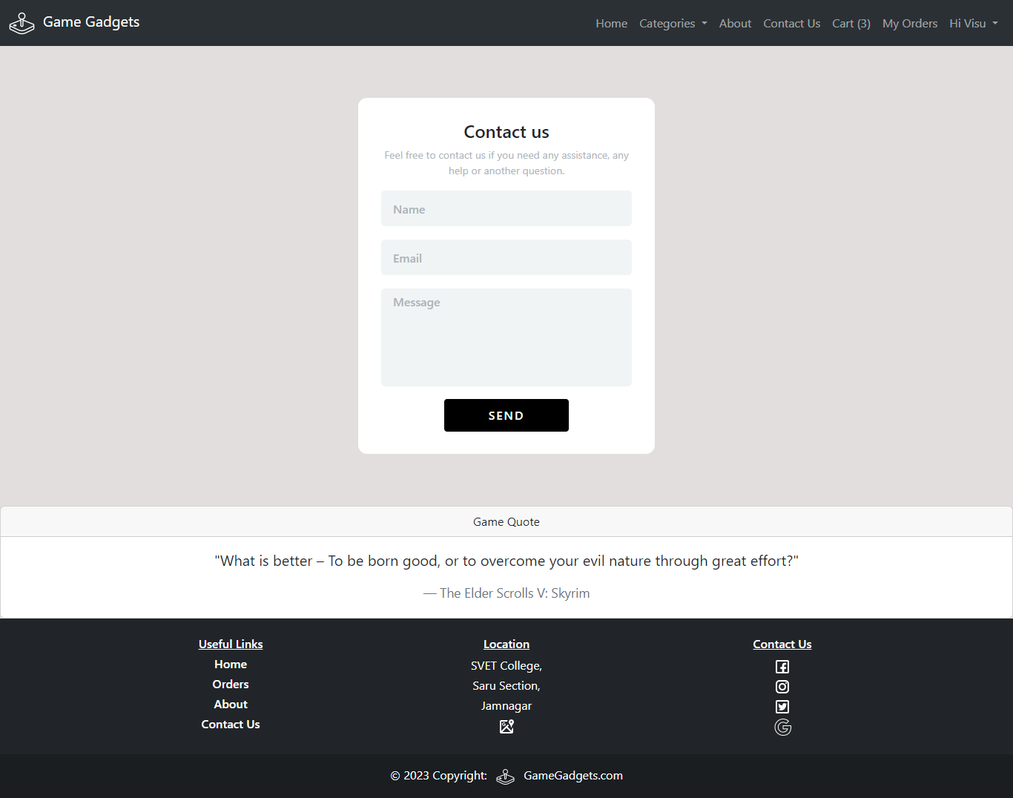

1. **My Orders:**

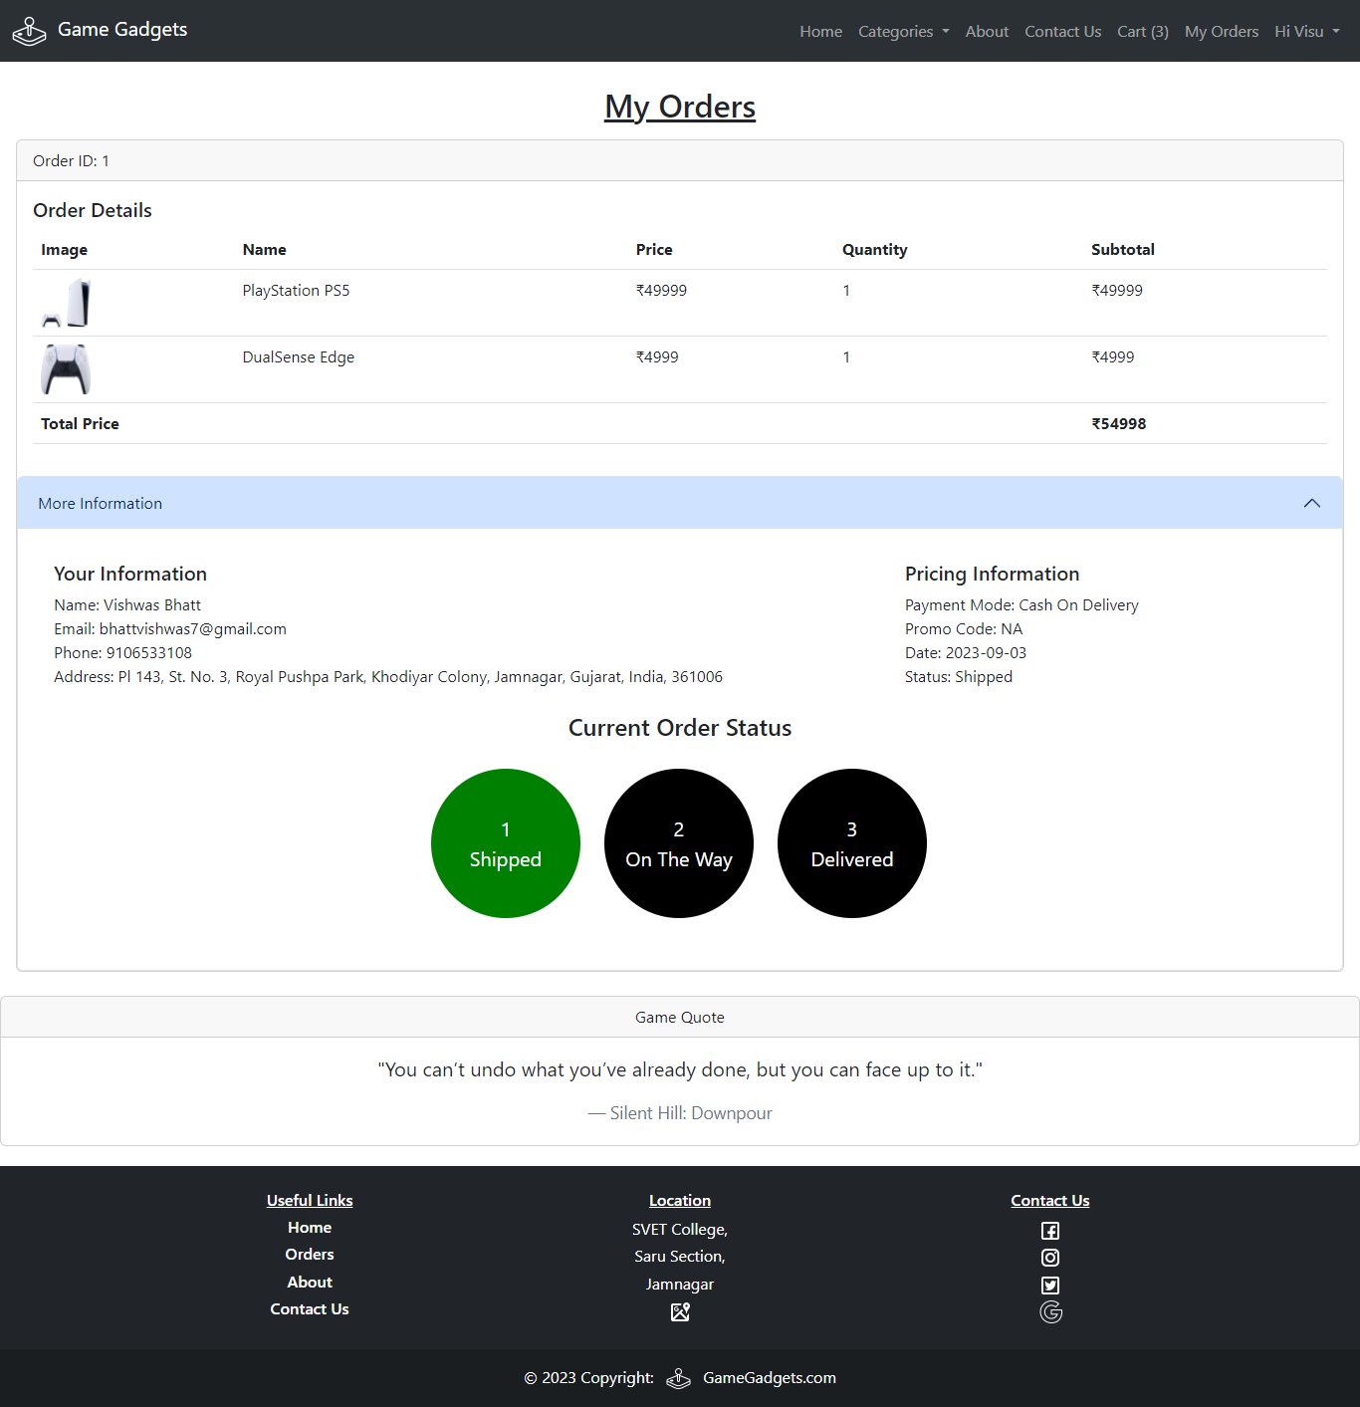

1. **About Us:**



## TESTING

|  |  |  |  |  |  |  |
| --- | --- | --- | --- | --- | --- | --- |
| **Test Case Id** | **Test Objective** | **Precondition** | **Steps:** | **Test**  **Data** | **Expected Result** | **Post-condition** |
| Test  Case-1 | Login page successfully  User login at Website. | 1. A valid account for login is to be available.  2. Home page is launched on a browser. | 1. In the login panel, Enter the username  In the username field. | Incorrect Username or Password | Successfully logged in for the given username if the user is valid, the login process is successful;  Otherwise it is not to be corrected.  The user cannot go the next page. | Because of cookies there may be issues for new users. |
| 2. Enter the Password  in password field in the login page | Incorrect Username or Password |
| 3. Click “Login” Button |  |
| Test  Case-2 | Going into cart page. | Choose the items you want to purchase then click on “Add To Cart” button. | 1. View the cart table that was generated from the product you selected. | If user select the products to buy then cart is not empty otherwise cart is empty. | Order is placed successfully placed if user follows right procedure. | If user not done this procedure then order can’t be placed. |
| 2. If you want to add more items after viewing your cart, click on “Continue Shopping” |

|  |  |  |  |  |  |  |
| --- | --- | --- | --- | --- | --- | --- |
| Test  Case-3 | Update the quantity of product in cart page. | A product is added to cart which a customer want. | 1. In the cart table select the product which customer wants Increase/  Decrease. | If the user not click update button then product quantity will not update. | Product quantity updated successfully with total price and grand total. | If user don’t perform this then the order take default quantity 1 which is settled by admin. |
| 2. Then  click on  “Update” Button. |
| Test  Case-4 | Apply promo-code in checkout page | A promo code can be redeemed by the customer. | 1. On right side of checkout page cart items and total is shown below that promo code is asked. (It is optional) If user have promo code then they can redeem to get specific rate of discount. | PROMO123  NEWUSER13  TESTINGS00  SVET10  LETSGAMEIT  GAMING007  (New Codes will Added or existing can be Deleted by Admin) | Promotional code is redeemed successfully discount and discounted price is as shown  below. | If user does not apply promo code then by default total price is taken as final price. |
| 2. After that Click On  “Redeem”  Button. |

* 1. **MAINTENANCE**
* We provide comprehensive security measures for user login. On the website, only individuals who have been granted authorization are able to place orders, while users who have not logged in or registered are unable to put their orders.
* Furthermore, it is more imperative that we continue to uphold and ensure the preservation of our security measures in the foreseeable future.
* We shall endeavor to consistently update and include new features and products on a regular basis.
* If user have any queries, they can provide feedback using our “Contact Us” page. For complaints users have the option to either visit our physical store or send an email, the details of which can found on our “About Us” page in our website.

## LIMITATION AND FEATURES FOR FUTURE ENHANCEMENT

* **LIMITATION:**
  + All applications and system possess built-in limitations that are common across various software platform. Every software or application possess natural limits.
  + I have made a concerted effort to stick to all the restrictions outlined in this context. However, I encountered certain challenges that impeded my ability to fully address certain of these restrictions. These challenges were mostly attributed to the complexity of my coursework, the time constraints imposed, and my level of expertise in the subject matter.
  + As a result, my application has some limitations.

1. Managing huge database poses significant challenges.
2. It is advisable to refresh the record source after each transaction.
3. The validation of data types is limited by time constraints, preventing the provision of an in-depth list of valid data types and their corresponding lengths.

## FUTURE ENHANCEMENTS:

* + In the future, it is anticipated that the MYSQL database system will be capable of supporting a sustainable no. of databases without encountering any issues.
  + Like the mentioned system, not all facilities are encompassed by it as a result of limitations in knowledge and time.
  + The current iteration of this application has undergone significant improvements in the terms of user-friendliness, allowing users to efficiently navigate and interact with its interface by utilizing keyboard inputs as an alternative to relying solely on a mouse.
  + However, we have also implemented upgrades on this website to ensure that all clients have access to see and purchase products form our platform.
  + In the future, we aim to integrate hardware products into our online store and provide further user-friendly features.
  + The concept of completeness is absent in the world. There are also errors present in our website. Efforts will be made to reduce and eliminate them.
  + We will endeavor to provide an online payment feature.

## CONCLUSION

* + The primary objective of the website is to streamline the process of accessing and presenting detailed information.
  + In this website all the records are stored in database so it is very simple to store the data and manage data. This feature proves to be useful for administrators who wish to preserve and organize their desired information.
  + Additionally, the user interface is designed in a manner that facilitates easy comprehension and navigation.
  + **Data security:** It is safe. Only admins with a login name and password can perform data backup and restoration tasks. The admin must enter a password in order to run the program. If any user tries to login with its username and password then it won’t work.
  + **Future Scope**: It terms of future prospects, it is recommended to enhance the management of records inside the database, particularly considering the potential increase in data volume, including both user-specific information and overall database size.

## BIBLIOGRAPHY

* **BOOKS:**

#### Complete web developing using PHP & MYSQL

* + Php beginner’s practical guide
  + Web based application using php

## WEBSITES:

#### [www.stackoverflow.com](http://www.stackoverflow.com/)

* + [www.icons8.com](http://www.icons8.com)
  + www.geeksforgeeks.com
  + [www.wallpaperflare.com](http://www.wallpaperflare.com)
  + [www.kidadl.com](http://www.kidadl.com)
  + www.w3schools.com